MATHEMATICAL COMMUNICATION CAPABILITIES BASED ON GENDER

Dimas Alfarisyi¹⁾, Sugeng Sutiarso²⁾
^{1,2}KIP Megsiter Pendidikan Matematika, Universitas Lampung
^{1,2}Jl. Prof. Dr. Sumantri Brojonegoro, Gedong Meneng, Kec. Rajabasa, Kota Bandar Lampung, Lampung
E-mail: dimas.alfarisyi38@gmail.com¹⁾, sugengsutiarso7@gmail.com²⁾

Abstract
This study was aimed to know the mathematical communication skill of eighth grade students of SMP IT Insan Mulia of Batanghari based on gender in solving questions about circle material. The subjects of this study consisted of 21 male and 21 female students. The research method used is descriptive qualitative. The data collection instrument used in this study is test; the mathematical communication skill test instrument consists of three questions in the form of essay. The results showed that female students had better abilities in explaining or representing ideas in each indicator about students' mathematical communication skill. The mathematical communication skill score of male and female students in general are 39 which are in the low category.
Keywords: Mathematical Communication skill, gender, circle material

INTRODUCTION
Mathematics is a basic science that must be introduced early to be mastered by students. This is one of the important lessons that must be introduced in both formal and non-formal education (Murtafiah; 2016; Rizta and Antari; 2018). One of the objectives of introducing mathematics is students will be able to solve problems by using symbols or language in mathematics. This is in line with the opinion of Pratiwi (2015) stated mathematical language can be used to explore and consolidate to make development in solving problems. It shows that mathematics is an important lesson for students to master because there are mathematical symbols or language that can represent a problem so that it is easy to solve.
The ability to represent a problem by using symbols or mathematical language is one part of mathematical communication skills. Lestari and Yudhanegara (2015) stated that the ability of mathematical communication is the ability to convey, understand and accept an idea both verbally or written carefully, analytically, critically and evaluatively. Mathematical communication skills can be seen from several indicators and aspects. Baroody (1993) stated mathematical communication skills have 5 aspects namely representing, listening, reading, discussing and writing. Representation is the ability of students to use mathematical symbols or language to solve a problem. Listening is the ability of students to receive ideas carefully from the teacher or other students. So that it will train someone to have a critical and careful attitude in giving opinions. Reading is the ability to understand the contents of a question well. Discussing is the ability of students to express their opinions directly from a problem well. Writing is the students' ability to convey their ideas in written form. NCTM (1989) stated that the indicators of students' mathematical communication abilities are the ability of students to convey their ideas and draw them in writing, the ability of students to understand, interpret and examine a problem from a picture and the ability of students to use mathematical language or symbols to create mathematical models, draw relationships and convey an explanation of a problem.
Each student has different mathematical communication skills. One of the factors that influence it is gender. Hodiyanto (2017) stated gender is one of the factors influencing students' mathematical communication abilities. Based on research by Untarti and Subekti (2016) stated that males have better abilities in presenting problems in diagram form and females have better abilities in providing explanations of problems. In addition, Cahyono (2017: 50) argued that the critical thinking skills of female students are better than male students. So the ability of mathematical communication by gender is different whether it is communication skills or critical thinking. For this reason, the researcher analyzed the mathematical communication skills of students in circle material based on gender.

RESEARCH METHODS
This research is a qualitative descriptive study. The subjects of this study were students of class VIII of SMP IT Insan Mulia Batanghari. The number of VIII grade students was 42 students consisting of 21 male students and 21 female students. The data collection used is a test. The test of mathematical communication skills consists of 3 questions in the form of a description. The data from the test results were analyzed with descriptive statistics. The mathematical communication skills of students are categorized based on the classification of the following table.

Table 1. The Criteria for Mathematical Communication Skills
Score | Criteria
$$85≤S≤100$$  $$70≤S<85$$  $$65≤S<70$$  $$55≤S<65$$  $$55>S$$ | Very good  Good  Enough  Poor  Very Poor

RESEARCH RESULTS AND DISCUSSION

Based on the mathematical communication ability test instrument that has been done by eighth-grade students, the following results were obtained:
Figure 1. Student's Mathematical Communication Ability Score

Description:
Indicator 1 | : | The ability of students to express their ideas and draw it in writing.
Indicator 2 | : | The ability of students to understand, interpret and examine a problem from an image.
Indicator 3 | : | The ability of students to use language or mathematical symbols to make mathematical models, draw relationships and convey explanations of problems.

Based on Figure 1, the following is a score of students in working on mathematical communication ability test questions consisting of three questions. Student scores in working on the questions on indicator 1 are 59 which is in the poor category. The score of mathematical communication ability on indicator 2 is 13 which is in the very poor category and the score of mathematics communication ability on indicator 3 is 10 which is in the very poor category. So overall the score of students' mathematical communication skills is 39 which is in the very poor category. The following is presented in more detail the results of a mathematical communication ability test-based on gender consisting of 21 male students and 21 female students.
Figure 2. The average Score of Students' Mathematical Communication Skills Based on Gender

Based on Figure 2, we can know that the mathematical communication skills of female students are higher than male students on each indicator. Students' mathematical communication skills on indicators Students' ability in conveying their ideas and drawing in writing is higher 4, on the indicator of the ability of students to understand, interpret and examine a problem of a picture is higher 2, and on the indicator of Students' ability to use language or mathematical symbols to make mathematical models, drawing relationships and conveying an explanation of a problem is higher 4. The following are the results and explanations on each indicator of students' mathematical communication skills.

Indicator 1 | : | The ability of students to express their ideas and draw in writing.
Question 1 | : | It is known that circle O has a diameter of 10 cm and has a central angle of AOB 120 ° and a circumference angle of ACB, ADB, and AEB.  - Draw the circle and determine the size of ∠ AEB!  - Is there a big relationship between the central angle and the lean angle? Try to explain!

Based on the mathematical communication skills test instrument on the ability of students to convey their ideas and draw them in writing, following is displayed the total of students who got score 0, 1, 2.3 and 4.
Figure 3. The number of Students Getting Scores of 0, 1, 2, 3 and 4 at question number 1
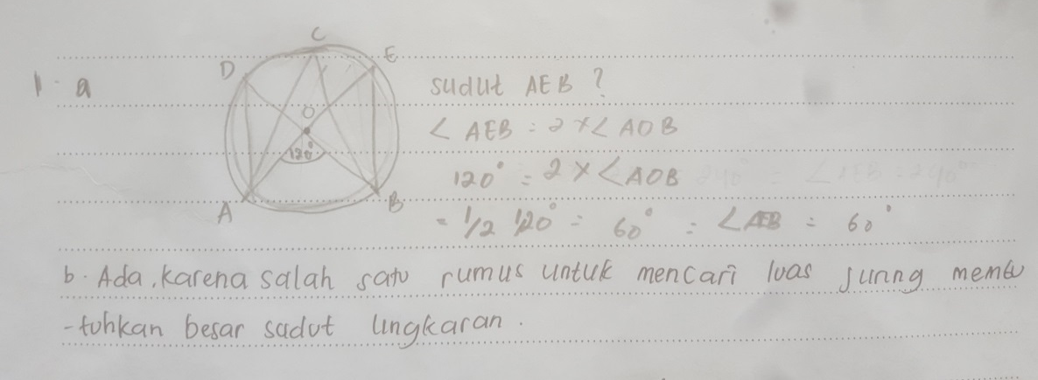
Based on Figure 3, we can see that female students have the ability to express ideas verbally, in writing and demonstrate in a better visual form in answering and giving explanations from male students. This can be seen from the results obtained score; from 21 female students, there are five female students who got the highest score (4). While, from 21 male students, there is no student who got 4. The highest score was got by 3 male students. The following is displayed the work of male and female students who get the highest score on indicator 1.

Figure 4. The Answer of Male Students at Question 1

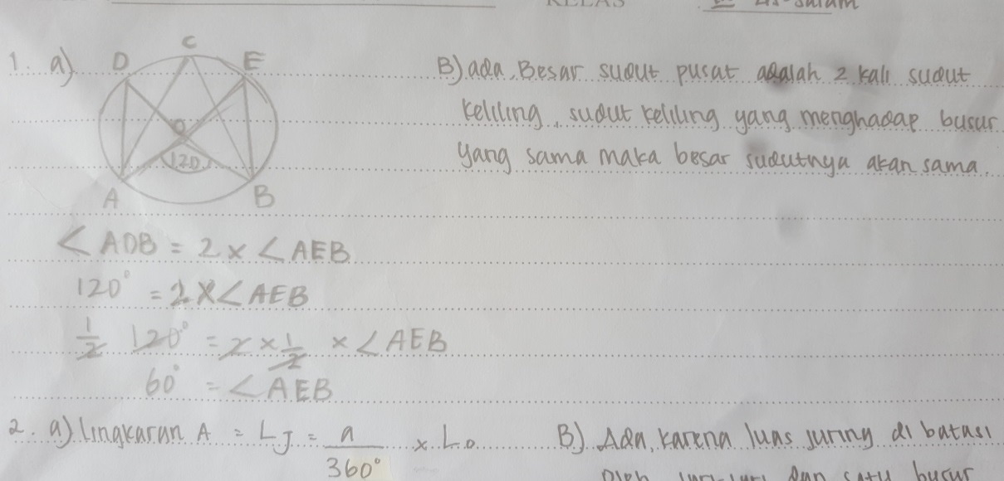

Figure 5. The female students' answer at question number 1

Based on the answers of male and female students on indicator 1 namely the ability of students to submit their ideas and draw them in writing. Male and female students can draw a circle and determine the angle size of ∠ AEB. But in providing an explanation of the relationship between the central angle and the circumferential angle, female students can explain precisely with the explanation that the magnitude of the central angle is 2 times of the circumferential angle. The explanation of male students is not right because it does not link between the large central angle and the circumferential angle in the circle. In providing an explanation of the relationship between the central and peripheral angles, students must understand the concept well and be able to explain the relationship in written form.

Indicator 2 | : | The ability of students to understand, interpret and examine a problem from an image.
Question 2 | : | Please look at the following picture:  From the pictures of Circles A and P, please determine:  a. The large section area of circle A and circle P!  b. Is there a relationship between a large angle with the area of the circle on the circle? Explain it!

Based on the mathematical communication ability test instrument on indicators of the ability to understand, interpret, and evaluate ideas both verbally and in other visual forms. The following is displayed the total students who got score 0, 1, 2, 3 and 4.

Based on Figure 6, we can see that the indicators of the ability of students to understand, interpret and examine a problem from a picture. Female or male students still have difficulty in solving the problem. This can be seen from the acquisition of the highest score obtained, namely male and female students only got the highest score (1). The number of students who got a score of 1 was more dominant to female students. The following is displayed the work result of male and female students who got the highest score on indicator 2.

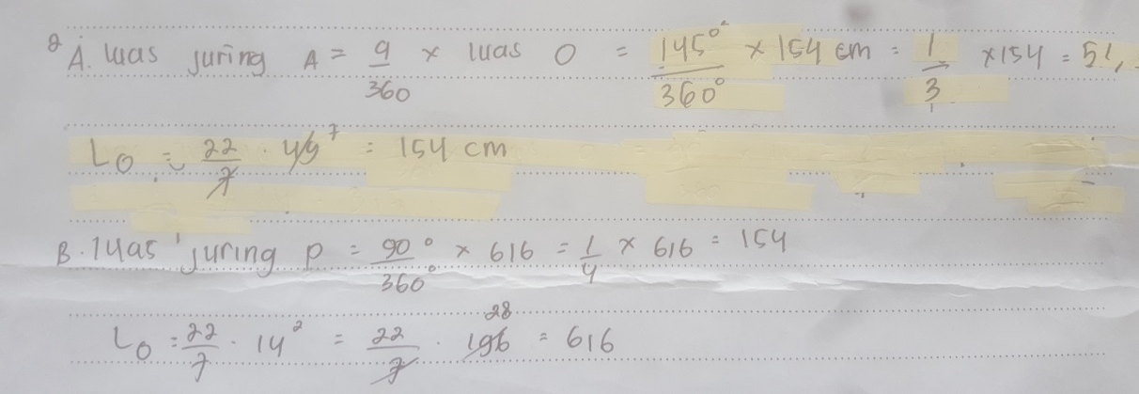
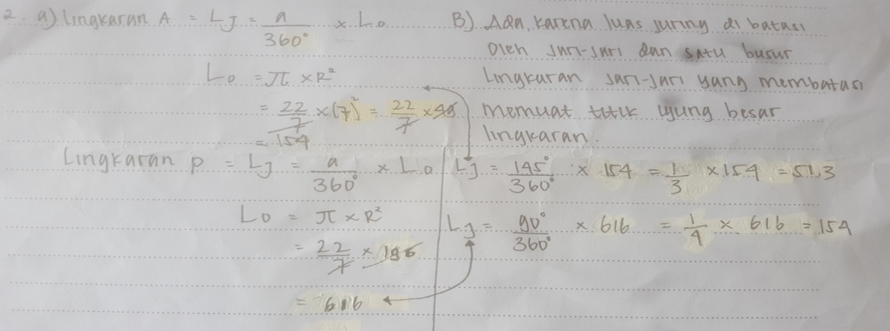
Figure 7. The Male Students' answer in Question 2
Figure 8. The Answers of Female Students in question 2
Based on the answers of male and female students in indicator 2; the ability of students to understand, interpret and examine a problem from an image. Male and female students can understand the picture in the problem well, it can be seen from the answers of students who know the length of the radius and the size of the circle A and circle P. Male students in determining the area of the segment in the circle A and circle P did errors in operating algebra so students' answers were incorrect. Male students also cannot evaluate to explain the relationship between the size of the segment in the circle. While female students only have errors in operating the algebraic form in determining the width of the A circle's segment. Female students also explain the relationship between the area of the width of the circle's segment, even though the explanation is incorrect the female student can represent the idea in written form. To answer the wide area of circle A and P, firstly, students understand the concept of the width of the circle's segment, so the students can determine the size of the circle's segment and give an explanation of the relationship of the width of the circle's segment well. In addition, the lack of carefulness of students in performing algebraic arithmetic operations causes the calculation of the area of segment to be incorrect.

Indicator 3 | : | The ability of students to use language or mathematical symbols to make mathematical models, draw relationships and convey explanations of problems.
Soal 3 | : | A running championship will be held at the Bung Karno Stadium.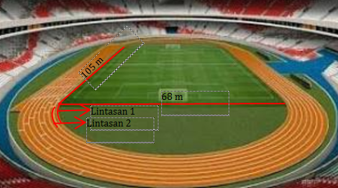  Lane 2  Lane 1  If the distance of each track is 100 cm. Please determine:  a. How long is the length of track 1 and line 2?  b. If the race that will be held is an 800m run. Will lane 1, lane 2 and lane 8 have the same start and finish lines? Please explain it well.

Based on the test instrument the ability of students to use mathematical language or symbols to make mathematical models, draw relationships and convey explanations of a problem. The following is shown the number of students who got score 0, 1, 2, 3 and 4.

Figure 9. The number of Students Getting Scores of 0, 1, 2, 3 and 4 at question 3

Based on Figure 9 we can see the ability of students to use language or mathematical symbols to make mathematical models, draw relationships and convey explanations of a problem is still very low. This can be seen from the number of students who did not answer the questions and the answers given were not right so that the maximum score obtained by students was only 1. The following is displayed the work result of male and female students who received the highest score on indicator 3.

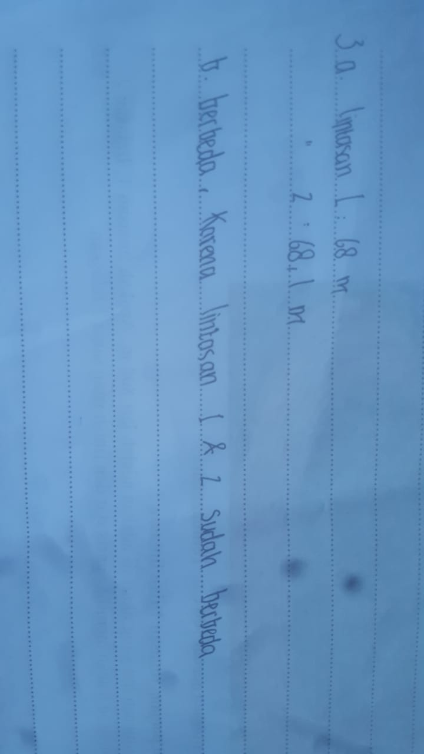

Figure 10. The Answer of male students at question 3

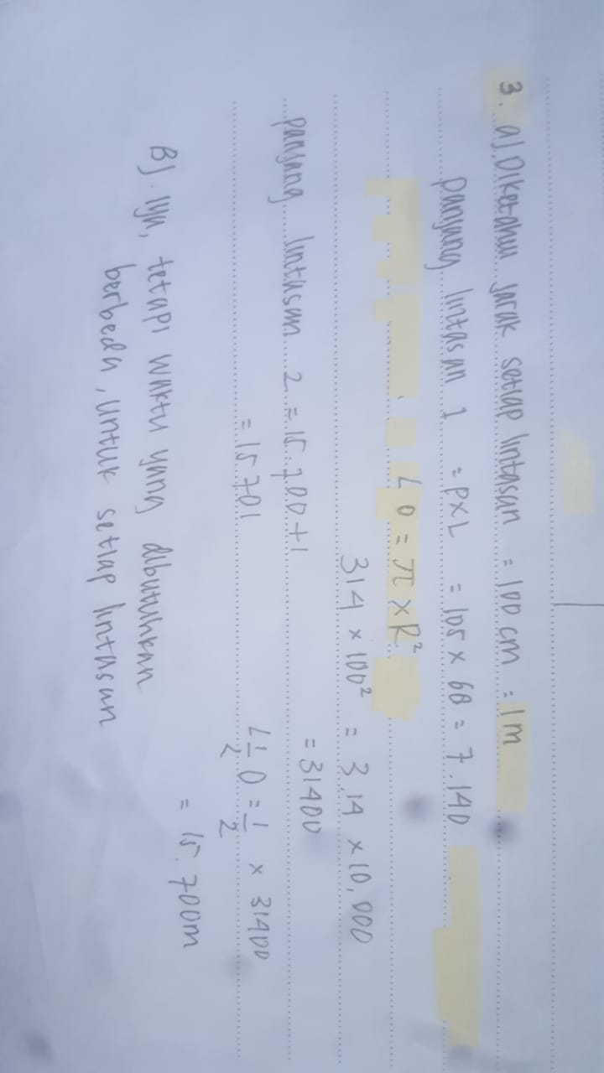

Figure 11. The answer of Female students at question 3

Based on the answers of male and female students in indicator 3, the ability of students to use language or mathematical symbols to make mathematical models, draw relationships and convey an explanation of a problem, male and female students got difficulty in answering questions. Male students immediately answered the length of the lane without using the notation of terms, mathematical notations, and their structures to present ideas, describe relationships and situational models. In addition, in giving explanations male students just explain without connecting them with concepts in mathematics. So the answers and explanations of male students were incorrect. Female students have already used mathematical notations, and their structures to present ideas, but they were not able to explain precisely the reasons whether lane 1, 2 until 8 have the same start and finish line. This is because students did not fully understand the picture so they experienced errors in determining the length of the radius. In working on the problem, students should first pay close attention to and understand the picture at the question, then use mathematical notations and symbols. To determine the length of lane one we can find the area width of a square with the formula p × l and the area width of a circle with the formula πr ^ 2.
Female students had a better ability to provide explanations or represent ideas in each indicator of students' mathematical communication skills. This is in line with the opinion of Zakiri, et al. (2018) and Kusumaningsih, et al. (2018) which stated that female students have better abilities in representing mathematics, models and conveying ideas. One of the factors that cause different mathematical communication skills between male and female students is the different ways of thinking in solving a problem. Sutiarso (2019) explained that one of the causes of these differences is due to the different anatomy of male and female brains. These differences cause male and female students to have different perspectives on solving problems. In solving problems, female students have good and well-arranged planning in answering questions (Yuliana and Winarso; 2019).
CONCLUSION
Based on the discussion, it can be concluded that the mathematical communication skills of female students are better than male students in each indicator of mathematical communication ability, but overall students' mathematical communication skills are still in the poor category.

REFERENCES

Baroody, A.J. 1993. Problem Solving, Reasoning And Communication. New York: Machmillan Publishing.

Cahyono, B. 2017. Analisis Keterampilan Berfikir Kritis dalam Memecahkan Masalalah Ditinjau Dari Perbedaan Gender. Akioma. 8 (1): 50 – 64.

Hodiyanto, H. 2017. Pengaruh Model Pembelajaran Problem Solving Terhadap Kemampuan Komunikasi Matematika. Jurnal Riset Pendidikan Matematika. 4 (2): 219 – 228.

Kusumaningsih, W. Saputra, H.A. dan Aini, A.N. 2018. Cognitive Style and Gender Differences In A Conceptual Understanding Of Mathematics Students. Journal of Physics Conference. 1280 (2019) 042017.
Lesatari, K.E. Yudhanegara, M.R. 2015. Penelitian Pendidikan Matematika. Bandung: Reflika Aditama.

Murtafiah , W. 2016. Kemampuan Komunikasi Matematika Mahasiswa Calon Guru Matematika Dalam Menyeesaikan Masalah Pesamaan Diferensial Ditijau Dari Gender. Jurnal Math Educator Nusantara. 2 (1): 31 – 41.

NCTM. 1989. Curriculum and Evaluation Standards for School Mathematics. Reston, VA : NCTM

Pratiwi, D.D. 2015. Analisis Kemapuan Komunikasi Matematik dalam Pemecahan Masalah Matematik Sesuai dengan gaya Kognitif dan Gender. Aljabar. 6(2): 131 – 14.

Rizta, A dan Antari , L. 2018. Pengembangan Tes Kemampuan Komunikasi Matematis Pada Materi Sistem Persamaan Linear Untuk Mahasiswa Calon Guru Matematika. Aksioma. 7(2): 291 – 299.

Sanjaya, W. 2013. Penelitian Pendidikan Jenis, Metode, Dan Prosedur. Jakarta: Kencana Penada Media Group

Sutiarso, S. 2019. The Ability Of Students’ Mathematical Proof In An Introduction To Group Theory In Terms Of Gender Differences. Jurnal Pendidikan MIPA, 20(2): 60 – 67.

Untarti, R. Dan Subekti, F.E. 2016. Kemampuan Komunikasi Matematik Mahasiswa Ditinjau Dari Gender Pada Materi Telaah Kurikulum SMP. Pyhtagoras. 5 (2): 139 – 150.

Yuliana, Y. Winarso, W. 2019. Penilaian Self Efficacy dan Kemampuan Pemecahan Masalah Matematika Berdasarkan Perspektif Gender. Jurnal Matematika dan Pembelajaran. 7(1): 41 – 60.

Zakiri, I.K. Pujiastuti, E. dan Asih T.S.N. 2018. The Mathematical Communication Ability Based On Gender Difference On Students Of XI Grade By Using Problem Based Learning Model Assisted By Probing Prompting Technique. Unnes Journal of Mathematics Education. 7(2): 78 – 84.

