Deskriptif statistik :
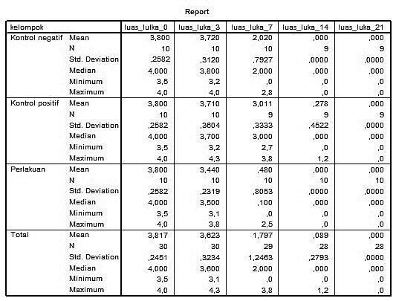

Uji normalitas data :

NPar Tests
Kruskal-Wallis Test
NPar Tests
Kruskal-Wallis Test

NPar Tests
Mann-Whitney Test

NPAR TESTS
/M-W= luas_lulka_0 luas_luka_3 luas_luka_7 luas_luka_14 luas_luka_21 BY
kelompok(1 3)
/MISSING ANALYSIS.

NPar Tests
Mann-Whitney Test

NPar Tests
Mann-Whitney Test

Oneway (Luas luka_3 data berdistribusi normal)

Post Hoc Tests

Homogeneous Subsets

