Figure 1. Neotype of Smilax klotzschii Kunth, Koorders 34990β (BO)

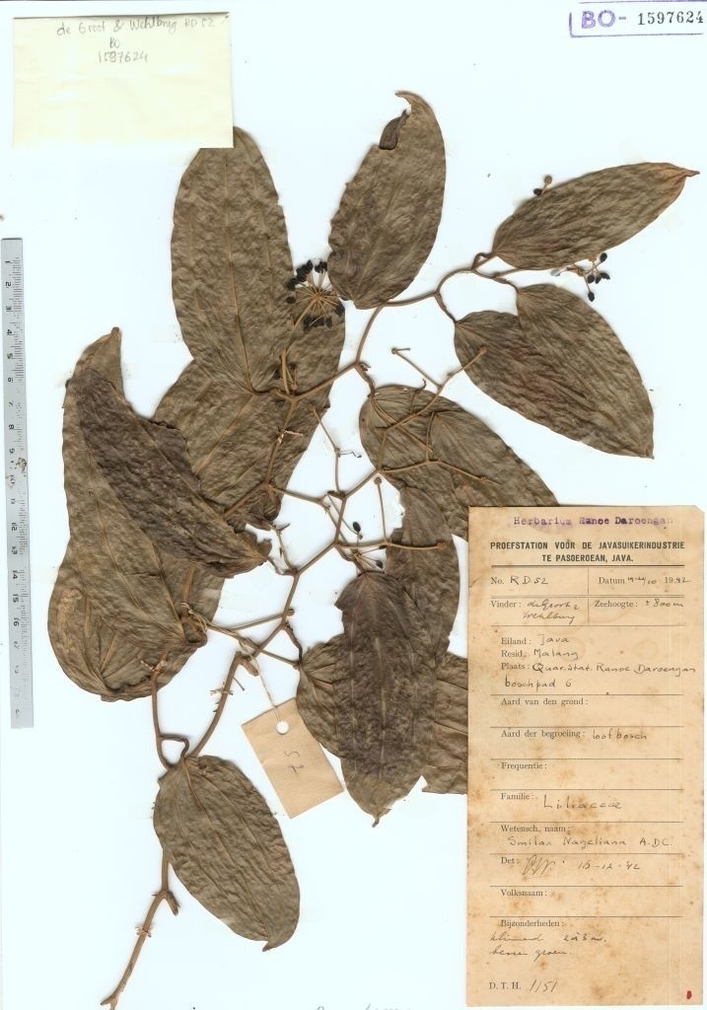

Figure 2. Neotype of Smilax nageliana A.DC, de Groot & Wehlburg RD52 (BO)
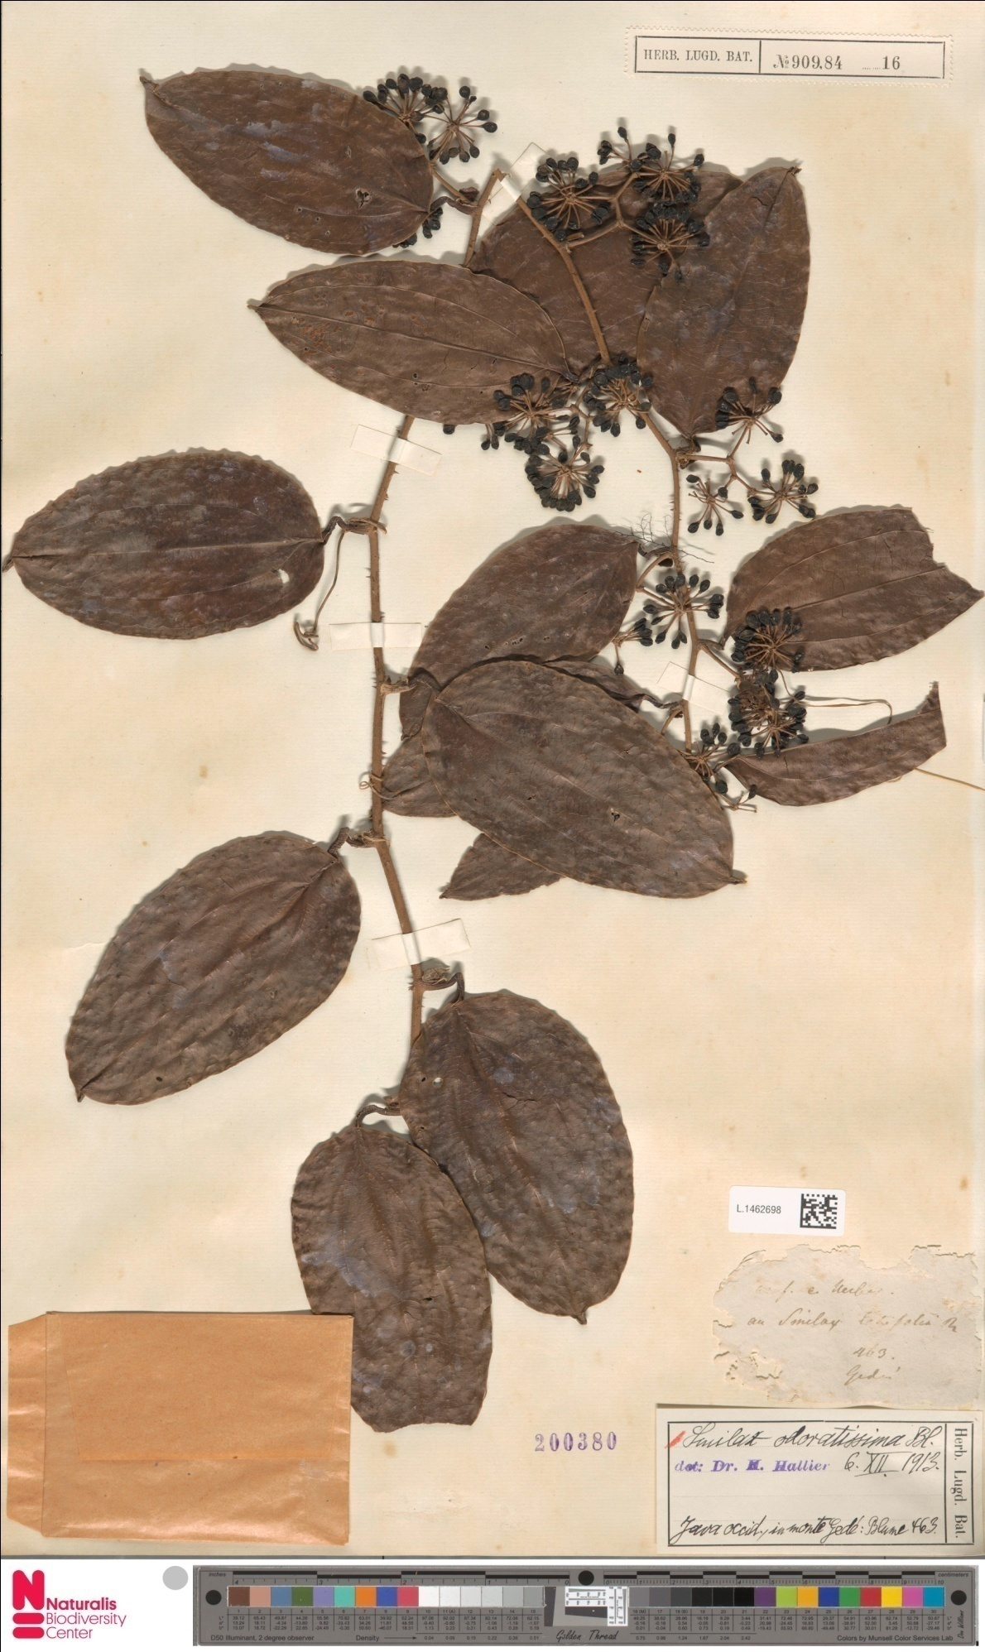
Figure 3. Neotype of Smilax odoratissima Blume, Blume 463 (L)

